E-BOOK

NETWORK CLOUD,

BETTER FOR OPERATIONS

What are the operational benefits of a disaggregated

network model?

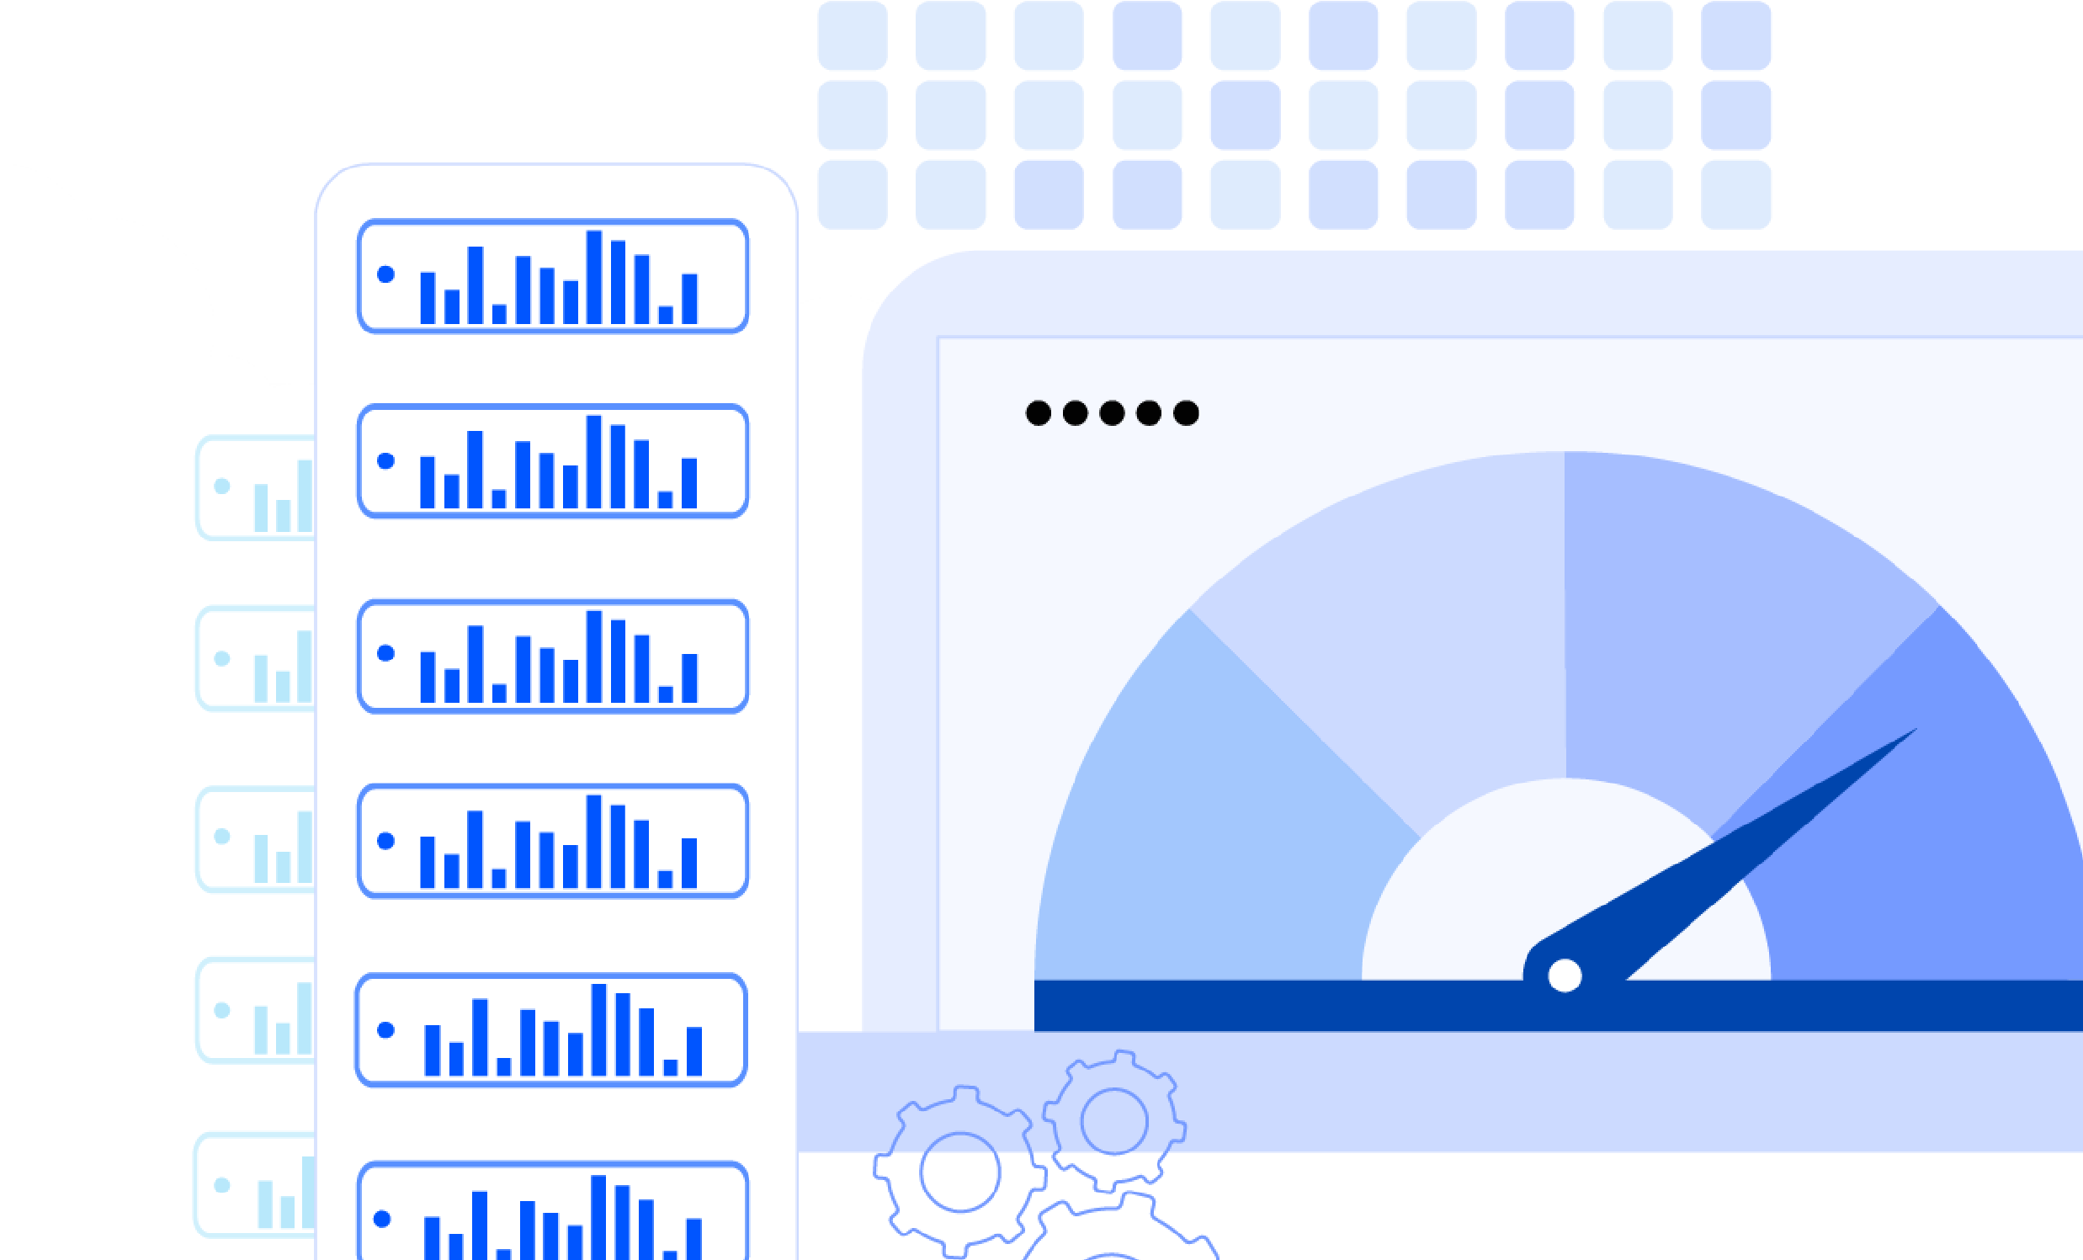

How Operations teams Benefit from DriveNets Network Cloud

The endless need for service providers to deliver increased performance and capacity continues to grow and take its toll. As a result, service providers are seeking better, more flexible, and more costeffective network architectures.

DriveNets Network Cloud, based on disaggregated cloud-native architectures, has already been deployed by many tier-1 service providers. Additional providers are expected to deploy Network Cloud in the next few years in their next-generation core, aggregation, peering and edge networks. However, there are still some providers that are concerned about the cloud-based model, particularly when it comes to network operations.

Operations teams can benefit from the many advantages provided by DriveNets Network Cloud. Its redesigned network architecture improves network flexibility and redundancy while maintaining familiarity among engineers.

Here are five main reasons behind the superior network operations of DriveNets Network Cloud.

**Higher availability, faster**

**recovery**

In case of a component

failure, the network

cluster continues to

operate seamlessly, and a

replacement can be done

on-the-spot

**Any router, only 2 types of**

**white boxes**

Building any network

function using only 2 types

of standard white boxes

**Built like a cloud, operated**

**like a network**

A familiar network operation

environment with improved

agility and scalability

**No forklift upgrading**

Scaling one white box at a

time vs. forklifting a large

monolithic chassis

**Multi-vendor,**

**one owner:**

Service providers select

the preferred responsibility

model

**01**

**04**

**02**

**05**

**03**

# 01 Higher Availability, Faster Recovery

Network outages can be devastating to the operator’s business, resulting in churn, lost revenues, and a decline in net promoter score (NPS). Therefore, service providers do all they can to avoid network outages; if one happens, they strive for a small blast radius and fast recovery so that the side effects of the outage will be minimized.

## Higher Availability

DriveNets Network Cloud architecture inherently enables high availability in software and hardware. On the hardware level, it includes built-in redundancies for any hardware element; if any component fails, the network cluster can continue to operate seamlessly. On the software level, DriveNets Network

Operation System (DNOS) combines classic router high-availability features, such as non-stop routing (NSR)/non-stop forwarding (NSF), with its cloud-native advantage of each microservice backed by another. Running every function on a dedicated container isolates each function and minimizes blast radius, so that a failure in one service will not affect the operation of other services on the shared infrastructure.

## Faster Recovery

Networks may fail, and this is true for any system. But DriveNets Network Cloud can assure network performance even when failures occur due to its inherent redundancy and fast recovery. Thanks to Network Cloud’s fully redundant disaggregated router model, even a fabric failure has no impact whatsoever on the router’s functionality and traffic-forwarding capacity. Furthermore, a replacement of a white box (fabric or packet-forwarding function) can be done immediately without scheduling or waiting for a maintenance window.

As opposed to that, when there is an issue in the fabric or backplane of traditional monolithic routers, the entire chassis needs to be replaced, which is a costly, timely, and burdensome process affecting network availability.

Disaggregated & Distributed Networking Legacy Networking

Architecture Architecture

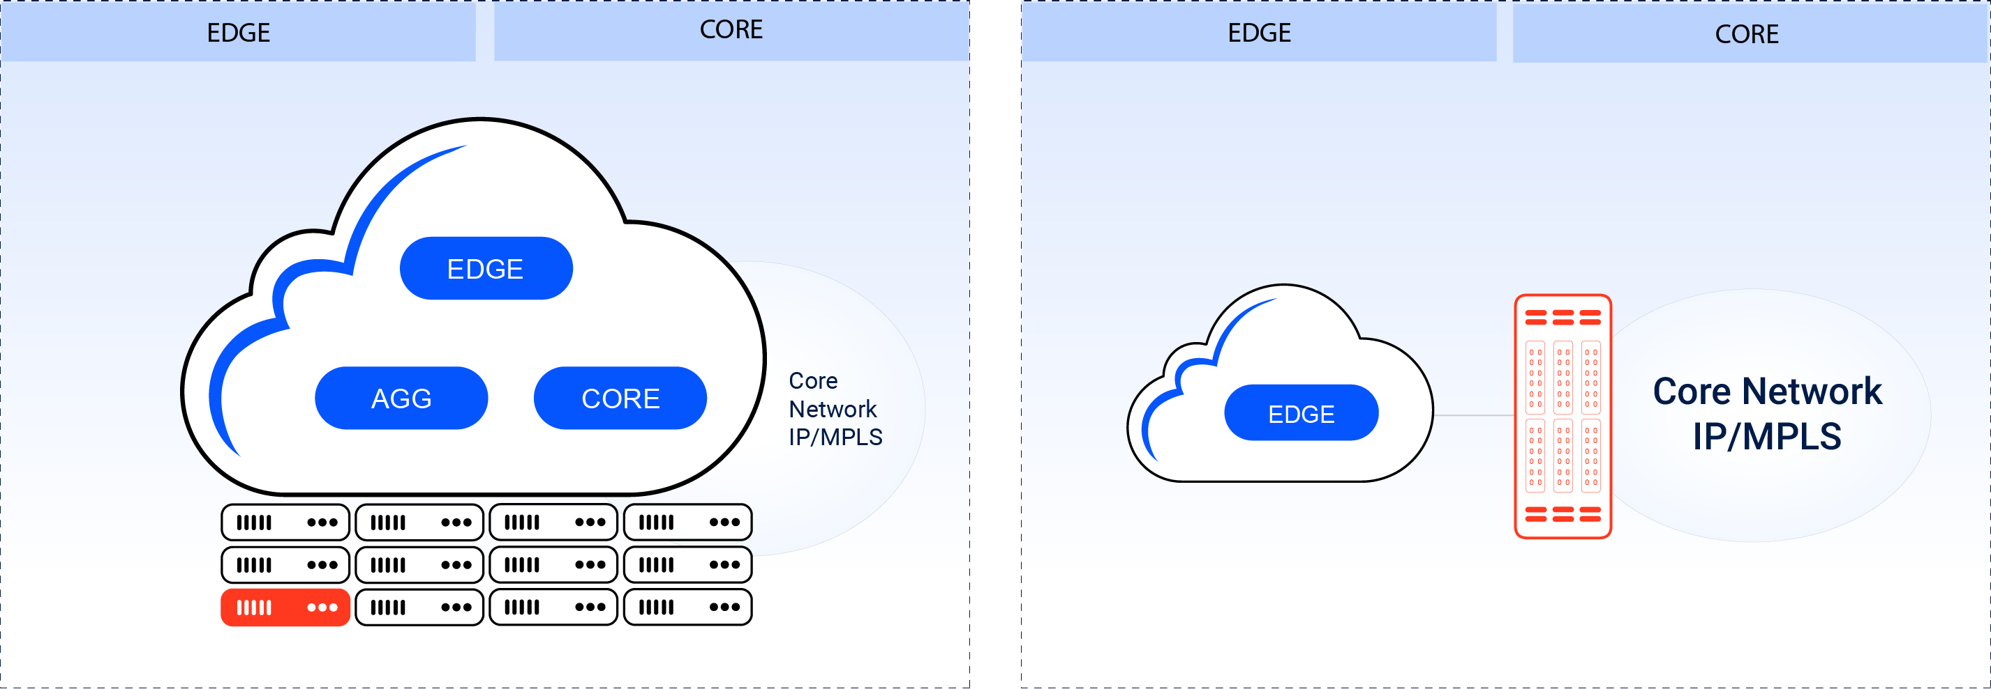

# 02 No ForkliftUpgrades

In the planning phase or in the event of network failure, traditional monolithic routers create many limitations due to their size and inflexible architecture.

DriveNets Network Cloud is different. It is based on a small form factor, with only 2 rack units in height. It uses standard white boxes – one for packet forwarding (NCP) and one for fabric (NCF) – that are deployable across all network domains. It can scale one box at a time up to a cluster size of 691Tbps. And service and maintenance are simple as well, as it is possible to replace any white box (NCP or NCF) on-the-spot without replacing the whole chassis.

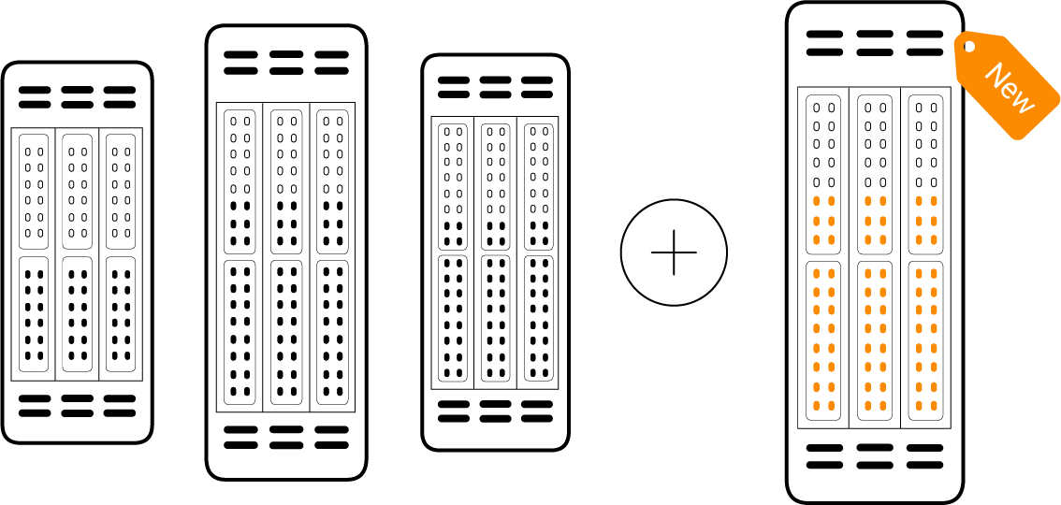TRADITIONAL

NETWORK

Scale = replacing the whole chassis

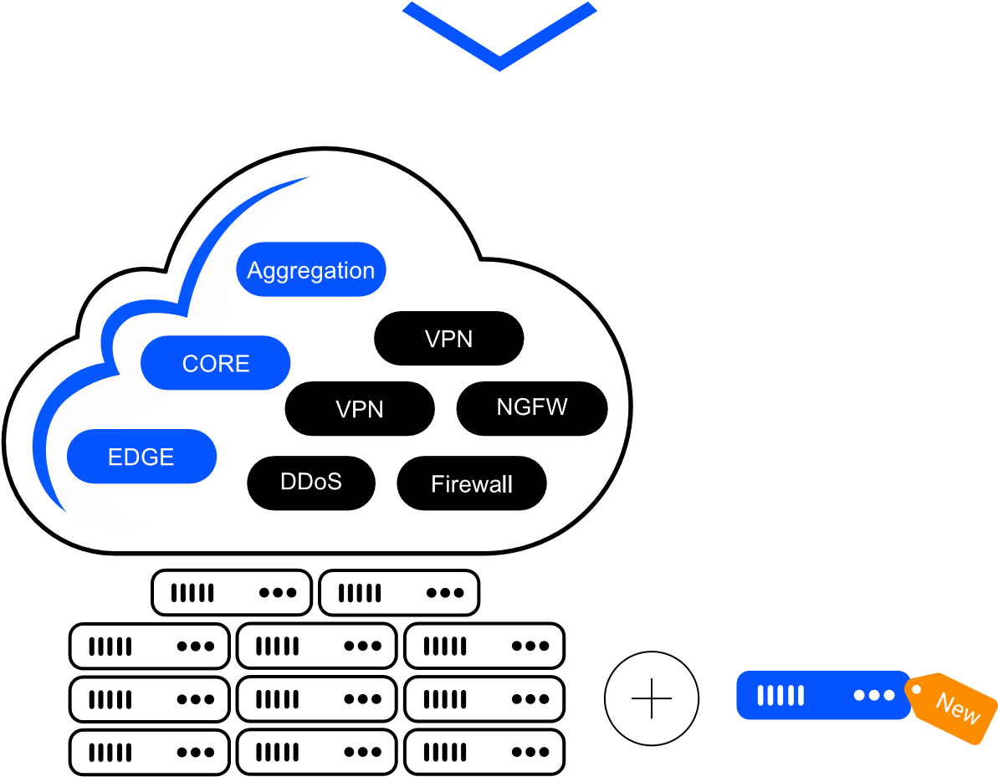DRIVENETS

NETWORK

CLOUD

Scale = One White Box at a Time

Traditional monolithic routers, on the other hand, require costly and time-consuming processes of planning, scaling and maintenance. The result is usually a forklift upgrade and a brand-new chassis model that replaces the entire system.

# 03 Built Like a Cloud, Operated Like a Network

Telecommunication networks today are built almost no differently from how they were built thirty years ago. New networking solutions based on distributed disaggregated chassis (DDC) architecture can improve resource utilization and scaling while innovating economic models. Yet some service providers are still reluctant to implement these solutions on a large scale.

One reason for this reluctance is the concern of network operations teams regarding new technologies and their unfamiliar operational processes. After all, any change potentially can impact their main KPI – network availability. To address this issue, service providers are looking for solutions that can provide frictionless operations on top of technological and business promises.

DriveNets Network Cloud offers the required agility with better scale-to-cost balance, while still offering the same familiar network environment. Network Cloud turns simple “off-the-shelf” white boxes into one orchestrated shared resource, over which network functions, like routers, are installed in a container. Therefore, any one of these network functions can be operated directly through a single command-line interface (CLI), just like a classic router.

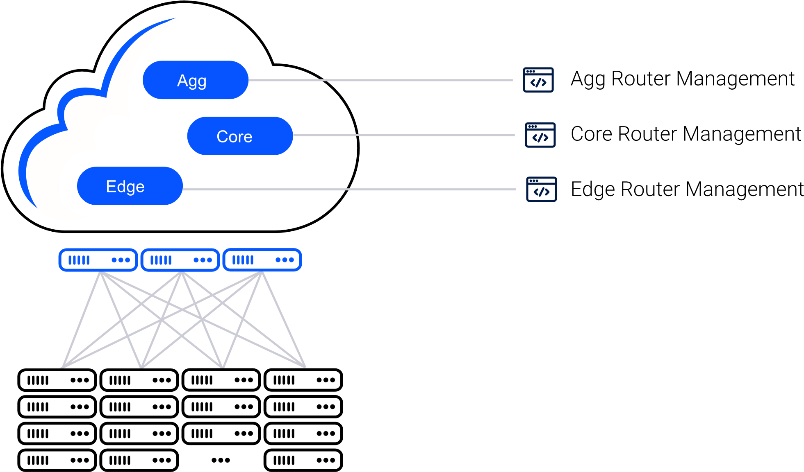

**Build network like clouds** - deliver agility with better scale to cost balance

**Frictionless operation** - a white box cluster behaves exactly like a regular router

## 04 Any Router, only 2 Types of White Boxes

When using traditional routing solutions, typically 5-20 different types of boxes are used in a network, on top of multiple line cards and other modules. When considering the operational processes of service providers, this is counterproductive.

The use of traditional routers entails a built-in compromise – different network domains require operating and maintaining numerous and completely different routing solutions. In addition, network operators are required to choose between two sub-optimal options. One option is to select devices that are optimized for immediate capacity requirements, but which must be replaced when capacity is exceeded. Another option is to invest in large underpopulated boxes and accept their associated high costs (CAPEX and OPEX), physical limitations, and complicated procurement and spares management. In short, traditional networking solutions are unable to deliver the agility and scaling required by today’s networks.

DriveNets Network Cloud, on the other hand, relies on only two standard hardware building blocks (NCP and NCF). These are not restricted to a specific chassis, can be deployed across any network domain, and meet any performance or capacity requirement. Service providers can build and maintain their entire network using only two types of white boxes, resulting in simpler and more cost-efficient planning, procurement, homologation, and spares management.

## 05 Multi-Vendor, One Owner

One of the perceived disadvantages of disaggregated networking architectures is that receiving technical support can be difficult. A multi-vendor solution (with one or more vendors for software, and one or more vendors for hardware) may lead to a “blame game” between vendors regarding a rootcause analysis. No matter what, when vendors start blaming each other it can become extremely difficult to solve the issue at hand.

DriveNets can offer any responsibility model required by the service provider. DriveNets can take endto-end responsibility for the solution, with any issue (software or hardware) subject to DriveNets’ SLA. If required/requested by the service provider, DriveNets can offer a shared responsibility model where the service provider leads hardware-related issues. With DriveNets, service providers can benefit from the multi-vendor model while eliminating their responsibility concerns.

## DriveNets Network Cloud Improves the Operational Experience

About DriveNets

DriveNets is a leader in cloud-native networking software and network disaggregation solutions. Founded in 2015

and based in Israel, DriveNets offers service providers and cloud providers a radical new way to build networks,

substantially growing their profitability by changing their technological and economic models. DriveNets’

solution – Network Cloud – adapts the architectural model of cloud to telco-grade networking. Network Cloud

is a cloud-native software that runs over a shared physical infrastructure of standard white-boxes, radically

simplifying the network’s operations, offering telco-scale performance and elasticity at a much lower cost.

For more information, visit us at

**www.drivenets.com**

After the dust settles following a marketing announcement about a great innovation, operations teams are the ones left to deal with any technical difficulties. Hence, a successful new technology must deliver superior network operations on top of its innovative and enhanced capabilities.

In addition to offering better, more flexible, and more cost-effective network architectures, DriveNets Network Cloud greatly improves the operational experience for service providers.

|  |  |  |  |  |  |
| --- | --- | --- | --- | --- | --- |
| Inherent  redundancy and  on-the-spot fix  Scaling one white  box at a time vs.  forklifting a large  monolithic chassis  **Higher**  **Availability,**  **Faster**  **Recovery**  **No Forklift**  **Upgrading** | |  | | --- | | **Built Like a Cloud,**  **Operated Like a Network**  Familiar network operation with  improved agility  and scale-to-cost balance | | |  | | --- | | **2 Types of**  **White Boxes**  **Any Function**  Building any network function  using only 2 types  of standard white boxes | | Flexible  responsibility  model  **Multi-Vendor,**    **One owner** |